All Children Thriving

A New Purpose for Education
By Pamela Cantor
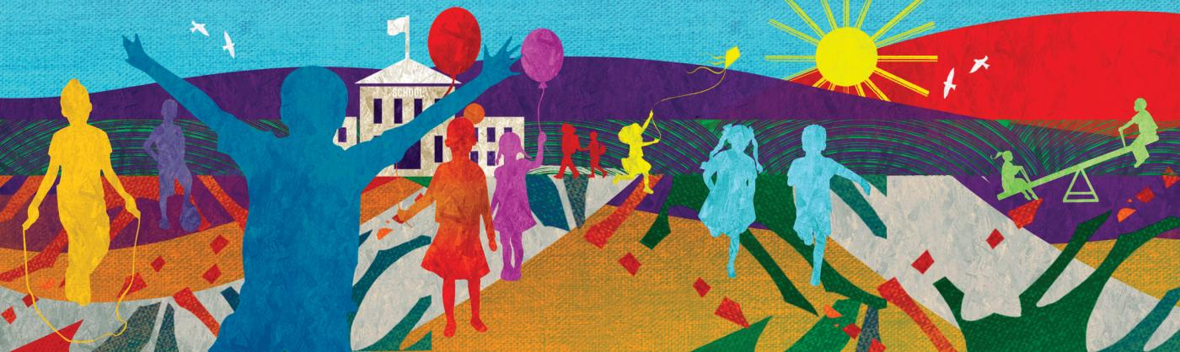
Education has long been central to the promise of the United States of America. But our current education system has never been designed to promote the equitable opportunities or outcomes that our children and families deserve and that our democracy, society, and economy now need. The people who built the education system in the 19th and 20th centuries believed that talent and skills were scarce. They trusted averages as measures of individuals. And many of their educational beliefs were grounded in racist stereotypes that deemed only some children worthy of opportunity. These beliefs influenced the learning and development ecosystem beyond school as well, such that access to high-quality enrichment opportunities were more often a reflection of wealth and zip code than need or interest.
COVID-19, the resulting recession in the service economy, and ongoing racialized violence have laid bare the inequities of experience and opportunity among our youth. They have also highlighted the resiliency of our young people, families, educators, and community organizations. When schools were forced to close abruptly and convert to remote instruction, teachers, school staff, and community partners stepped up to reinforce relationships, provide critical supports, and acknowledge both the losses and the learning happening. It can be hard to find silver linings when there has been so much suffering. But here is one: we now have a chance to design something different and better for all of our children.
In recent years, teams of educators, youth development practitioners, and researchers have been striving to dismantle our outdated system. Today, there is a new vision for learning and development emerging for all children across the United States:
Imagine a world where every child’s life was a succession of opportunities in which they come to know who they are and in which they discover who they could become…. Imagine too that educators could find how best to identify each child’s specific abilities, interests, and aspirations and then align these attributes with the specific contexts that best promoted the child’s talents, achievements, and successes in life. Finally, imagine that each child lived in a world that removed the constraints of racism, poverty, disparities, and injustices and provided them with the specific relationships and supports needed for thriving.¹
Intuitively, we know that each of our journeys through life is unique. They take place through an open-ended set of experiences that happen all the time and in every space in which we grow and learn across the lifespan. A comprehensive understanding of whole-child development, learning, and thriving requires a dynamic and integrated view of the journey each young person takes, namely the environments, experiences, and relationships they are exposed to. Current scientiﬁc understanding and measurement of these dynamic, individualized journeys must become the foundation for the beliefs, knowledge, and practices of all practitioners, administrators, and policymakers working with and on behalf of children. Speciﬁcally, they must understand the learning processes, potentialities, and capabilities that can and will emerge in students across time and across settings, especially when such settings are intentionally designed to promote whole-child development, learning, and thriving.

Whole-Child Development: A New Dynamic Understanding
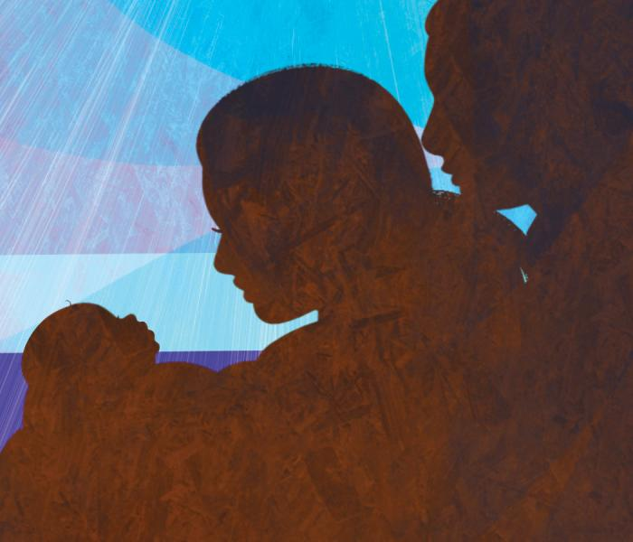“Whole-child development” can mean different things to educators, researchers, other child- and youth-serving professionals, and policymakers. Some define it relatively narrowly, focusing on integrating health services and programs more deeply into the day-to-day life of schools to ensure that all students are healthy, safe, engaged, supported, and challenged.² Others include an explicit reference to the inclusion of instruction for social and emotional learning (SEL).³ Still others offer a more expansive concept, seeing whole-child development as a comprehensive approach building on a young person’s assets and on the understanding that (1) physical conditions, emotional states, and pro-social experiences (i.e., caring relationships) have a direct impact on learning and (2) student success and well-being must be conceptualized and measured* to include more than academic skills and knowledge acquisition.⁴
These views are based on research and were crafted to challenge the status quo of learning and education in the United States. Still, as explained below, these viewpoints do not offer a complete picture of the multiple dimensions of human development, including and importantly, how children become learners.⁵
Multiple bodies of research and methods of analysis afﬁrm that child development (and human development in general) is dynamic, bi-directional (i.e., the child and context influence each other), and individualized. It results from both nature and nurture. More specifically, it results from each person’s biology, developing brain and body, psychology (social, emotional, and cognitive development), and gene expression, and from each person’s parental, familial, educational, communal, environmental, cultural, and societal influences.⁶
The takeaway? Learning happens everywhere all the time, among all young people in all settings.
But our systems were not designed with this knowledge. In fact, no single system—neither public schools nor youth development organizations—can fully address the whole child or involve the whole community. This is not because education leaders or equity advocates think academic success is the only goal. Nor is it because youth development organizations believe that building relationships, experiences, and opportunities that support youth thriving is more important than academic competence and credentials. It is because these leaders, like the leaders of related systems (such as child welfare, family supports, juvenile justice, and youth employment), think, see, and act using the language, goals, and metrics of their individual systems. Typically, they do not have the capacity or incentives to integrate broader youth ecosystems aimed at learning and thriving.
To begin this integration, we must carefully consider the word all. All young people at all ages in all settings have learning gifts and needs that should be documented, discussed, and seen by the systems they interact with as part of their individualized developmental path.⁷ All youth-serving systems should see themselves, and recognize each other, as active participants and partners in the endeavor to educate and prepare whole children, whether they are in public schools or community-based organizations. All settings are places where learning and growth occurs; that includes family rooms, classrooms, gyms, cafeterias, athletic fields, rehearsal spaces, playgrounds, community centers, and more.† All learning approaches contribute to a child’s development of skills, competencies, agency, and identity to various degrees. All adults need more substantial and sustained training, supports, and resources (including time) to optimize the experiences and relationships they build together with children.
The goal? All children thriving.
In this article, and in the real-world school- and community-based work it represents, my colleagues and I have chosen to focus on thriving because we believe that our approach to whole-child development will enable programs and policies (both in and out of school) to promote positive and healthy development for all young people, including those who have experienced signiﬁcant adversity and oppression. Everyone involved will need to understand, believe in, and embrace the dynamism and complexity of learning, development, and thriving as integrated processes and not seek to oversimplify them at the expense of many learners.
Before offering a more comprehensive description of our vision for whole-child development, I want to present some current misconceptions and distinctions about resilience and thriving, why our current educational systems demand so much resilience from our least-advantaged youth, and thus why resilience is not enough.

The Difference Between Resilience and Thriving
Resilience and thriving are different but connected processes. They both represent positive adaptation to life events. Resilience offers us a picture of adaptive functioning in high-risk or adverse settings. Whereas thriving focuses on optimal functioning, resilience attends to adequate or “okay” functioning, largely because resilience research has focused on children and families facing enormous challenges, adversity, or trauma.⁸
Thriving itself is a dynamic process that goes beyond well-being to include individual growth that is positive, strengths-based, and multidimensional, across multiple domains, including physical, emotional, and cognitive. Thriving reflects the optimization of a young person’s holistic, adaptive response to their experiences of community, family, culture, and learning settings.⁹
Today, researchers, educators, and policymakers are becoming more aware of individual children’s sensitivities to the effects of cumulative stress.¹⁰ These stresses are often associated with socioeconomic and relational inequities and the stresses experienced by their caregivers, family members, teachers, and child workers.¹¹
Adverse stressful experiences occur both inside and out of school. When they are severe, sustained, and not buffered by protective factors such as positive relationships, they influence a young person’s thoughts, feelings, behaviors, and attainments in any learning setting. Disparities in opportunities and marginalization based on race, ethnicity, gender, religion, community, access, income, and/or other intersectional aspects of identity prevent the chances for thriving.¹² Belief in one’s ability to grow, learn, and succeed through education may be more important than any specific curriculum for predicting and nurturing educational outcomes and life successes. But unfortunately, for marginalized students, this belief is shaped significantly by racial, ethnic, and gender stereotypes and by discriminatory practices, including inadequate funding to schools in low-income communities. In short, multiple factors influence a child’s growth and development, for good or for bad.

Historical and Longstanding False Assumptions in Public Education
Public education in the United States was designed long before researchers and practitioners had an understanding or knowledge of developmental and learning science and therefore was based in part on a set of false assumptions. The table below presents these false assumptions and corrects them with current knowledge and evidence.
False assumptions about learning | Evidence-based concepts about learning
Genes are the primary determinant of learning and development (rather than contexts). Contexts and relationships (in and out of school) are secondary contributors to skill development and mastery of content. Intelligence and cognitive abilities are ﬁxed, and personality is stable. (In common terminology, this view prizes nature over nurture.) | Contexts—relationships, environments, and experiences in and out of school—are the primary determinants of learning and development.¹³
Talent and skills are scarce, distributed in a bell curve (i.e., with most people clustered in the middle near average). Speciﬁc students (in many cases white students or, even more narrowly, middle- and upper-class white boys) have talent and skills (determined by genes); other students (mainly students of color, students from low-income families, and girls) do not. The system should be designed to identify and support (i.e., select and sort) those with innate talent and skills. | Talents and skills are ubiquitous. Education should be designed to reveal the talents and skills in each child.¹⁴
An average score on a test usually administered once a year represents a student’s competency and is a good enough approximation of what the student knows. Measuring to determine an average score is sufﬁcient for understanding the competency of individuals. | There is no such thing as an average child; an average of anything rarely represents any attribute of the individuals being measured.¹⁵
Memorization of content and facts will lead to mastery, competence, and higher-order thinking skills. Measurement of content acquisition is a good representation of student competency. | Mastery of content, competencies, and higher-order thinking skills comes when educators scaffold and teach essential skills and engage each child with challenging, relevant content within the child’s zone of proximal development (i.e., what is challenging but not frustrating) during each period of development.¹⁶
The potential of a student as a learner is knowable in advance; some children arrive at school ready to engage in learning (especially white children from middle and upper socioeconomic status families), and others (especially children of color from lower socioeconomic status families) do not. Skill and competency development are discrete, linear, and measurable. Growth trajectories are predictable. | The potential of a child is not knowable in advance. The purpose of education should be to develop and extend the talents and potential in each child. Human development is a jagged process with peaks and valleys along the way and with additional growth almost always possible.¹⁷
Student agency and students’ beliefs about intelligence are not relevant to identity formation and do not require adjustments in expectations and opportunities by leaders and teachers. Speciﬁcally, children of color are assumed to be growing up in poverty, ill-suited to educational settings and academic rigor, and even prone to criminality. | Student agency and students’ and teachers’ beliefs about intelligence are highly relevant to identity formation.¹⁸
Adversity does not disrupt learning or developmental processes. | Adversity can have effects on the neural systems that govern learning and behavior, but with support from caring, trusted adults, these effects are preventable and reversible; children can overcome the effects of adversity and thrive.¹⁹
Most 20th-century learning environments did not reflect the integrated, dynamic, and individual nature of human development that we now know undergirds the learning process itself. Across the country, public education focused on delivery and acquisition of content—primarily mathematics and English language arts—using standardized approaches and was not designed to intentionally develop the learner or to promote equity. With funding largely driven by local property taxes, the system was designed to offer rich learning opportunities to certain groups often residing in specific zip codes, but not to groups marginalized because of their race, gender, and culture.²⁰ Indeed, the US education system was designed to select and sort, and institutionalized racism, classism, and segregation remain embedded in the system to this day.²¹
Fortunately, developmental and learning science tell an optimistic story about what all young people are capable of. Children’s brains and bodies are malleable. The contexts and relationships they are exposed to are the primary drivers of who they become and of the expressions of their genes. (For a closer look at the keys to human development, see the box below.) The rest of this article focuses on translating that science into action, discussing how adults can use the principles of whole-child design to build environments in all the settings children inhabit: classrooms, cafeterias, camps, libraries, parks, playgrounds, buses, etc. This will enable children to thrive: to cope with stress, build resilience, develop 21st-century skills and mastery-level competencies, and live self-directed lives with many opportunities for fulfillment.

Human Development: Key Concepts
Here, I summarize key concepts in human development, using a dynamic systems approach, to explain the unfolding story of how an embryo becomes a human being. The concepts are sequenced to account for the beginning: the embodied miraculous nature of the embryo itself, containing all the structures it will need to become a whole human being. Then, I offer an explanation of the opportunities and constraints in relationships and experiences across the lifespan that bring about the expression of fullest potential of the embryo.
Embodiment: The human body is composed of many biological subsystems. Less obvious are the ways these biological subsystems carry the history of what they have experienced thus far in their lives; this is known as the principle of embodiment. For example, whether or not an individual has consistently had adequate nutrition, sleep, safety, and shelter is recorded within every cell and structure of the human body.
Context: Together, the environments, experiences, and relationships of a human life form its context for development. Context has several levels of organization, including the biological (the systems of the human body) and the social, cultural, and physical world in which the child grows up. The most common example of positive context is the human relationship itself, and the most common example of negative context is the experience of stress.
Culture: Culture frames the way individuals construct and make meaning of every facet of their lives, founded on their specific histories. This means that learning is a social, relational, and cultural process.¹ Culture functions as a set of meanings, practices, values, and artifacts, including and importantly, language.
Holism: Context and culture provide the foundation for the principle of holism, which means the whole defines the parts and the parts define the whole.² We see this every day. Think of a sentence. The letters form words and the combination of words form the sentence. Yet if we only looked at the letters or the words, we would not understand the meaning of the sentence. As our embryo grows into a young adult, it develops based on its relationships and experiences, into its very own unique self.
Plasticity and malleability: Plasticity refers to the ability of individual cells to change based on experience and the contexts they are exposed to. When cells change, structures and systems in the mind and body change; as this happens, we change. This is what is meant by the malleability of human beings to experience, positive or negative. This capacity to change based on experience is what affords the greatest opportunities in development—and also the greatest risks.
Relationships: The bonds between and among children and adults represent a primary process through which biological and contextual factors influence the plasticity of the developing brain and body. Relationships that are reciprocal, attuned, culturally responsive, and trustful constitute a positive developmental force between children and their physical and social context.
That relationships are important is not new knowledge.³ However, we must define “relationship” in a way that accounts for the power of relationships to shape development in constructive ways, including at the cellular level. One pair of researchers conceived of “developmental relationships” as having four characteristics: enduring emotional attachment, reciprocity, progressive complexity of joint activity, and a power balance that allows for transferability to new settings.⁴ They and others hypothesized that these four factors are the active ingredients in effective interventions across settings.⁵
Neural integration: The catalyst for the developing brain is an activation process that depends directly on human relationships. The process by which brain structures become connected and organized to produce increasingly complex skills is called neural integration.
One crucial and unique property of the human brain is its ability to self-organize in response to the contexts it is exposed to. This can happen in adaptive or maladaptive ways depending on the supports or constraints of experiences.⁶ Self-organization of the brain means that the person, as a complex living system, will build and organize increasingly complex skills to attain specific goals. Those goals may promote growth and even survival or evolve to solve a speciﬁc problem, such as the process of learning itself.⁷ This unique and profound organizing and processing power of the brain, through pathways of billions of neurons, yields the particularly unique human ability to remember experiences, compare them with other experiences, and generalize what has been learned to future experiences.
–P. C.

Endnotes
1. B. Rogoff, The Cultural Nature of Human Development (New York: Oxford University Press, 2003).
2. W. Overton, “Process and Relational Developmental Systems,” in Handbook of Child Psychology and Developmental Science: Theory and Method, vol. 1, 7th ed., ed. W. Overton and P. Molenaar (Hoboken, NJ: Wiley, 2015), 9–62.
3. A. Masten, Ordinary Magic: Resilience in Development (New York: Guilford Press, 2014); and National Scientific Council on the Developing Child, Young Children Develop in an Environment of Relationships: Working Paper No. 1, Center on the Developing Child, Harvard University, 2004.
4. J. Li and M. Julian, “Developmental Relationships as the Active Ingredient: A Unifying Working Hypothesis of ‘What Works’ Across Intervention Settings,” American Journal of Orthopsychiatry 82, no. 2 (2012): 157–66.
5. D. Siegel, The Developing Mind: How Relationships and the Brain Interact to Shape Who We Are, 3rd ed. (New York: Guilford, 2020).
6. Siegel, The Developing Mind.
7. M. Mascolo and K. Fischer, “Dynamic Development of Thinking, Feeling, and Acting,” in The Handbook of Child Psychology and Developmental Science: Theory and Method, vol. 1, 7th ed., ed. W. Overton and P. Molenaar (Hoboken, NJ: Wiley, 2015), 113–61.

A Dynamic Systems Approach to Human Development and Learning
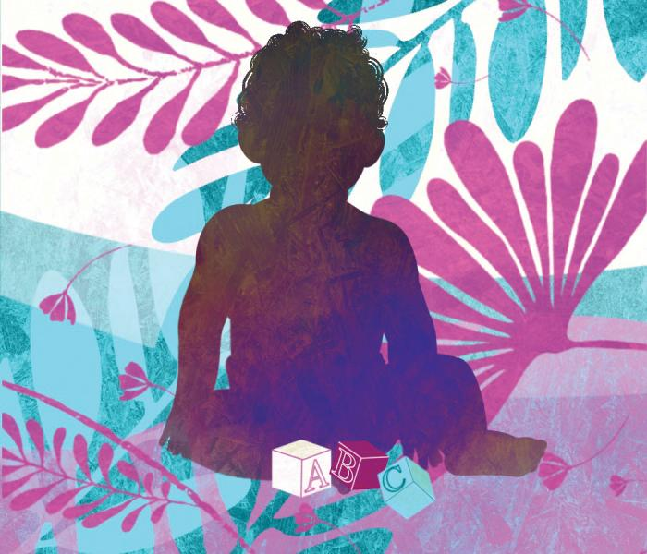When thinking about how to apply new science to reshape the 20th-century education system, it is helpful to begin by considering other fields. What was done when scientists learned that germs—not miasma—cause disease? When scientists learned that cancers can be transmitted, not like infections, but instead through gene mutations? Although health disparities continue to exist, and contribute to racial and socioeconomic inequalities, there have been dramatic changes in medicine in the last 50 years based on new knowledge. Cures for diseases, highly effective vaccines against COVID-19, and changes in how scientists conduct research and how physicians practice medicine have occurred in part because of willingness to challenge assumptions and take a holistic view of the biologic ecosystems that produce health and illness. In other words, scientists are willing to let go of old assumptions in favor of new knowledge and a dynamic systems approach. We must do the same for our learning systems.
Think about the human embryo. An embryo is an extraordinary feat of human development. It is a structure comprised of multiple substructures, with every future system that a human being will have or need represented. The embryo also contains the potential to interact with and influence all the other systems and structures involved in human life. The embryo is, therefore, a “pluri-potential” structure—meaning its potential development is not fixed—and it is a powerful example of the dynamic systems theories of human development. In fact, the embryo can be both the metaphor and lens through which we represent the structural sequences and processes that produce a whole human being who becomes an engaged, productive learner. At every moment throughout the human lifespan, environments, experiences, and relationships are activating the processes that bring each human being to life.
Positive development and thriving²² emerge from the integration of several individual and contextual systems, from the biological and physiological to the cultural and historical.²³ In this dynamic, relational, developmental systems framework, the life cycle of an organism is not preprogrammed genetically.²⁴ Rather, genes act as chemical followers, not prime movers, in developmental processes.²⁵
There are approximately 20,000 genes in the human genome. As packages of biological instructions, genes require signals to determine which processes are carried out, with social and physical contexts inﬂuencing if, when, how, and which genes are expressed.²⁶ The term “epi” comes from the Greek and means “over” or “above,” indicating that epigenetic effects are effects that are “beyond” the effects of genes.²⁷ This helps to explain why, in our lifetimes, fewer than 10 percent of our genes will ever be expressed—with context as an overwhelming determinant of which of our genes are actually expressed. The expression of individual potential rests on this one profoundly important point: that all children are malleable to experience, and experience is something that we can influence.
How does any complex skill develop? Through the interaction of the child and their context in pursuit of specific goals.
A child’s web of experiences can alter the ways in which complex skills develop. Multiple neural systems, not merely those associated with cognition, contribute to core learning processes, such as attention, concentration, memory, knowledge transfer, motivation, and generalization.
Complex skills, such as reading, mathematics, riding a bicycle, playing an instrument, or developing resilience, are competencies that are built when neurons connect to one another across brain structures. For example, the capacity to read involves seeing, hearing, comprehension, and expression; these different structures get wired together through the experience of reading. The consistent firing of neurons produces the “wiring” of the brain. In other words, as reflected in Hebb’s Law,²⁸ neurons that ﬁre together become wired together, which produces more deeply ingrained pathways and therefore increasingly complex skills. All complex skill development requires “practice,” meaning the more neurons fire and wire together, the more the brain develops the circuitry to execute complex skills fluently.
A seminal work on dynamic systems theory explains:
Skills do not spring up fully grown from preformed rules or logical structures. They are built up gradually through the practice of real activities in real contexts, and they are gradually extended to new contexts through this same constructive process. A skill draws on and unites systems for emotion, memory, planning, communication, cultural and historical scripts, speech, gesture, and so forth. Each of these systems must work in concert with the others for an individual to tell an organized story or perform a complex task in a way that it will be understood and appreciated.
And further that:
Skills are context-speciﬁc and culturally deﬁned. Real mental and physical activities are organized to perform speciﬁc functions, in particular settings.... The context speciﬁcity of skills is related to the characteristics of integration and inter-participation because people build skills to participate with other people directly in speciﬁc contexts for particular sociocultural and adaptive reasons. And, as a result, skills take on a cultural patterning.²⁹
It follows then that inequities of experience based on race, social class, gender, ethnicity, religion, ability status, or sexual orientation are not biologically mandated necessities of nature. They are disparities that exist based on false beliefs, prejudices, or oppressive policies established by privileged groups.³⁰ When such systemic societal inequities are addressed, the malleability of human beings to positive experiences and relationships can unfold.
Supporting the learning of a complex skill means that even the most discrete skill, like solving an algebra word problem, needs to consider the person learning or performing that skill. It means taking into account prior experience, culture, history, foundational skill development (in reading and math), identity (and identity threat), agency, and motivation. All these dimensions will be present in a whole child in the context of a classroom or other learning setting.
If educators teach only to discrete math skills, for example, some children will “learn it.” But if educators teach to the whole child, they can support all students to understand it, become curious to learn more, and be able to apply it to other problems. Students will build analytic skills and even discover parts of themselves they did not know about, such as, “maybe I am a math person after all.”

Developmental Range and Human Potential
“Developmental range” is the fullest expression of what each child is capable of—the child’s inner potential under highly favorable conditions—and creating those conditions is the doorway to the development of increasingly complex skills. Developmental range is the concept that has the greatest implications for the design of all learning settings and the training and preparation of adults within them.
Skill development, as described above, is variable and varies with context. There are no fixed patterns of intelligence or learning styles, no fixed stages or fixed end points. A child who can solve a math problem at night with parents or after school with a coach may not be able to solve the same problem in a classroom. A newly developing skill, in particular, can have a great range of levels of performance based on contextual factors—think about the effect of seeing an older sibling or friend perform the skill first. Opportunities for young people to “preview” a future skill with peers or under the guidance of adults are crucial for the cultivation of motivation, belief, confidence, willingness to take academic risks, and, most of all, seeing the emergence of their own capabilities. Conversely, the presence of unchallenging curricula, of stereotype threat, or of gender assumptions can contribute to the under-development and under-education of young people and undermine their belief in themselves as learners.

Building Blocks: An Empirical Developmental and Learning Framework
To more fully grasp the process for developing complex skills and how to optimize development and learning, one powerful framework is Building Blocks for Learning, shown below. This is a theoretical empirical framework that depicts the pathways for learning, cognitive development, and academic and life success across ﬁve levels (or tiers) of interconnected skill development. Learning and cognitive development rest on the possession of foundational skills, including positive social attachments, stress management, executive function, and self-regulation, each conceived of as a set of skills that all children would have the opportunity to develop in an equitable world. In that context, the possession of these attributes would enable children to develop skills that prepare them for success in learning, work, and life. These crucial skills form the foundation for the development of higher-order skills such as self-direction, curiosity, resilience, perseverance, and civic identity.
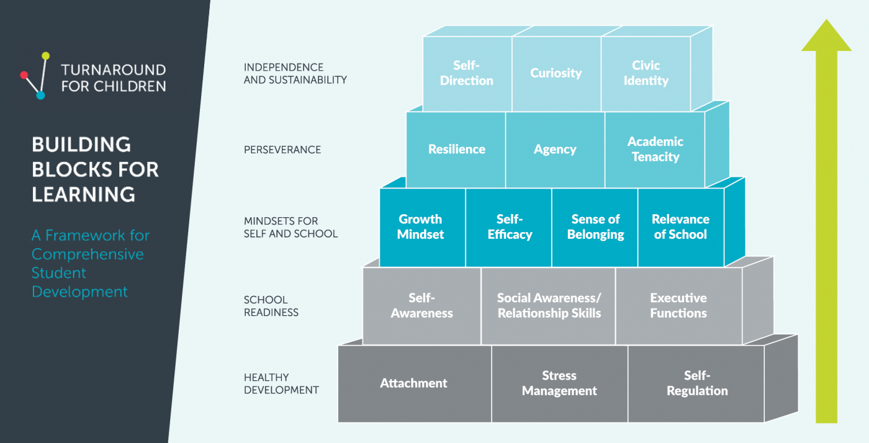
This framework helps us to understand what we see in any classroom: variation is the norm in the development of all learning skills. The pathways to developing skills are numerous. Learning happens in fits and starts with forward movement and backward transitions. It is, in fact, jagged. We see this when a student appears to go backward while a lower-level skill is consolidated before a more advanced skill can be mastered. We also see that skills can grow out of experiences outside the classroom, including sports or the arts, at just the right time to reveal a young person’s zone of proximal development.³¹

The Opportunity We Have Today
Over the last several decades, large-scale efforts to improve opportunities to learn have focused on interventions and programs that generate only incremental change, only for some children. What we need now is a transformational paradigm shift.
The dynamic concept of whole-child development, learning, and thriving that my colleagues and I have crafted emerges from research describing the malleability, agency, and developmental range of children as they draw on available resources and build a web of relations and experiences across multiple settings. If well-designed and intentional, these webs can provide the foundation for the development of complex skills that ultimately reveal the talent, passions, and potential of each child. Children’s pathways will be diverse and their patterns jagged. That lack of uniformity is appropriate because all children possess a broad set of potentialities across multiple domains (e.g., physical health; mental health; complex social, emotional, and cognitive development; core academic skills and knowledge; positive identity formation; agency) and each child is an integrated, dynamic system with virtually inﬁnite horizons.
To summarize, relationships, environments, and experiences will: drive the expression of each child’s genetic endowment and epigenetic attributes, harness the malleability of their bodies and brains, and nurture the fullest expression of what each child becomes.
In schools and other settings that aim to foster learning and thriving, the primary role of the adult is not to teach discrete skills, but to create opportunities for each child to want to bring their interests, passions, talents, prior experiences, culture, and existing capabilities to bear to master increasingly complex skills. Such settings will:
- Be attuned to the presence of biological, psychological, and sociocultural attributes of each child.
- Foster positive relationships in all aspects and activities.
- Integrate multidimensional practices to meet all learners where they are in their development across a diverse set of attributes to foster acting with agency and voice.
- Create conditions of support and opportunities for growth within and, critically, across settings to capitalize on the malleability of children and the variable and jagged pathways through which they will acquire increasingly complex skills and academic competencies.
- Capitalize on the speciﬁc strengths, and potential growth in the strengths, of each child to build the cognitive, social, emotional, metacognitive, and motivational skills and positive identity to enable the child to adapt to new challenges, including transferring skills to new settings.
- Address sources of institutionalized racial oppression, sexism, marginalization, stereotyping, and individual bias that diminish the opportunities for positive identity formation and the expression of an individual child’s potential.
- Be aligned with the resources for positive growth found in communities, families, schools, child development programs, faith-based organizations, culture-sustaining organizations, and athletics.
Nothing less than this elaborate, comprehensive web of environments, relationships, and experiences will optimize each child’s learning and healthy whole-child development.

Essential Guiding Principles for Equitable Whole-Child Design
The Guiding Principles for Equitable Whole-Child Design, shown below, is a framework that aims to guide the transformation of learning settings for children and adolescents.
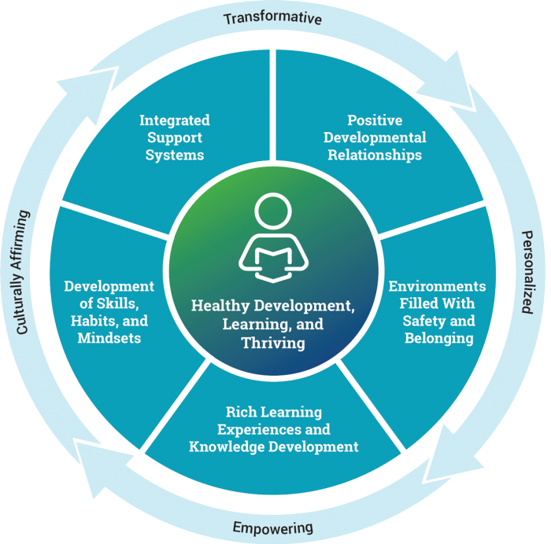
- Positive Developmental Relationships: Relationships engage children in ways that help them define who they are, what they can become, and how and why they are important to other people.
- Environments Filled with Safety and Belonging: Children struggle to engage and learn when they don’t feel safe physically, emotionally, and with regard to their identity—when they don’t feel like they and their culture are represented and valued in their learning community.
- Rich Learning Experiences and Knowledge Development: These are the kinds of intentional, nourishing, personalized instructional experiences that fully engage and challenge us, helping us discover what we are capable of.
- Development of Skills, Habits, and Mindsets: Because learning is integrated (there is not a math part of the brain separate from a creative part of the brain), we need to focus on developing skills like self-regulation, executive functions, growth mindset, and perseverance as part of mastering challenging content. Skills and content work together to produce problem solving, collaboration, and metacognitive and analytic skills, as well as mastery-level academic competencies.
- Integrated Support Systems: Learning environments need to be set up with many more protective factors, including health, mental health, and social service supports as well as opportunities to extend learning beyond the school day and build on interests and passions.
Although these principles resonate with many educators, they have not yet been widely used to develop schools and learning settings, nor have they been engineered in fully integrated ways to yield healthy development, learning, and thriving. Progress has been impeded by both historical, ingrained practices and current policy (which is built on dated, false assumptions about school design, accountability, assessment, and educator and practitioner development). The current educational system and the constraints built into federal law (e.g., requiring high-stakes assessments in reading and math) do not support robust implementation, let alone integration, of these practices. Nor do they prioritize deep connections across school- and community-based resources. If, however, the purpose of education is the equitable, holistic development of each student, scientific knowledge from diverse fields and sources can be used to redesign policies and practices to create settings that unleash the potential in each student.
Redesign around these core principles has implications for all levels of the ecosystem, from the classroom to the school, district, and larger macrosystems that must join together to produce an intentionally integrated, comprehensive developmental enterprise committed to equity of development, opportunity, and experience for all students, not just some. Although my colleagues and I separate and enumerate each principle individually, we believe the unique application of these principles will be to use them in reinforcing and integrated ways to truly support learners’ needs, interests, talents, voices, and agency. The aim is a context for development that is greater than the sum of its parts and is transformative, personalized, empowering, and culturally affirming for each student.

Our Shared Challenge: Bringing Whole-Child Design to Every School and Community
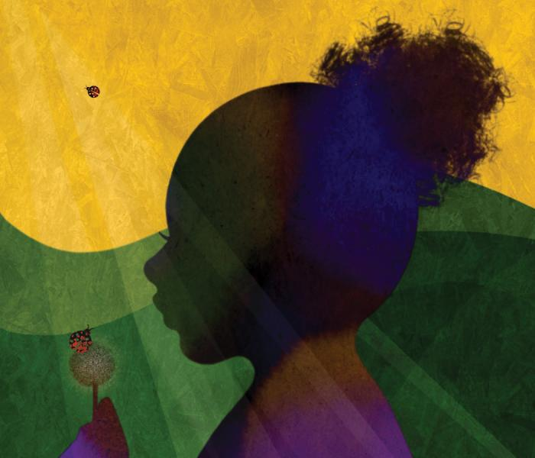“Not everything that is faced can be changed, but nothing can be changed until it is faced.”
–James Baldwin
It is not possible to talk about the development, learning, and thriving of young people without talking about opportunity, access, resources, and social capital. And it is not possible to talk about any of those things without talking about race. In How to Be an Antiracist, Ibram X. Kendi wrote:
What if, all along, these well-meaning efforts at closing the achievement gap have been opening the door to racist ideas? What if different environments lead to different kinds of achievement rather than different levels of achievement? What if the intellect of a low-testing Black child in a poor Black school is different from—and not inferior to—the intellect of a high-testing [w]hite child in a rich [w]hite school? What if we measured intelligence by how knowledgeable individuals are about their own environments? What if we measured intellect by an individual’s desire to know? What if we realized the best way to ensure an effective educational system is not by standardizing our curricula and tests but by standardizing the opportunities available to all students?³²
If the United States wanted to right the wrongs of today—and of 402 years of policies and practices since the first enslaved Africans arrived in modern-day Virginia—it would have to rethink systems based on the scientific principles outlined above, such as malleability, relationships, the importance of context, and human potential. The principles can serve as a guide to not only what we can do to benefit all young people’s learning and development, but also what we must stop doing now because it is actively harmful to the learning and development of many young people. This includes dismantling the institutions that preserve and sustain harmful, racist practices, such as tracking, harsh discipline, exclusion, shaming, and many others. It also includes embracing the cultural nature of learning.
Learning is inherently cultural.³³ As the lead editor of the Handbook of the Cultural Foundations of Learning explains:
To best represent what we know about human complexity and diversity, … a theory that captures the fundamentally cultural nature of learning must rest on four key propositions, viewing learning as:
- Rooted in our biology and in our brains, both of which science increasingly recognizes as social and cultural;
- Integrated with other developmental processes, whereby learning involves the whole person—emotion, cognition, and identity processes working together;
- Shaped through the culturally organized activities of everyday life, both in and out of school, and across the life course;
- Experienced as embodied and coordinated through social interactions with the world and others.
These RISE principles recognize that learning occurs across multiple developmental niches and timescales and is deeply contextual and social. Understanding the cultural nature of learning is critical for the design of schools and school systems that build trusting relationships, provide space for identity exploration and positive identity mirroring, engage with curricula with an eye toward identity and connection, and view family and community knowledge as core to disciplinary knowledge…. This approach is aligned with anti-racist teaching practices and fosters embracing multiplicity and understanding learning as integral to liberation and freedom.³⁴
Consider the power and influence you hold. Take a moment to think about who is walking into your programs and through your classroom doors and the variation you will see: You may have children who are happy, children who are anxious, children who are eager, and children who feel disconnected. You may have young people who have experienced trauma, who have lost loved ones to COVID-19, or who have supported their family and siblings after the loss of a job or a loved one. There could be students who have not been inside a school building for a year and a half but have learned how to cook, repair the family car, tutor their younger brother or sister, or play a jazz riff on the guitar. All of this and more is likely walking through your door. And then there is what COVID-19 brought to your own lives. So how can you be ready to welcome it, all of it, the good, the great, and the challenges you see before you every day? What are the nonnegotiables for your well-being and theirs?
There are assumptions and dominant narratives about what we are looking at: the trauma of COVID-19, the impact of racialized violence and historic inequities of educational opportunity, the problem of learning loss and lost learning time, the beliefs young people have about whether they and their identities and cultures are welcome in their learning communities, the fears young people have about their futures.
How many of our students, particularly those most vulnerable, will internalize these messages about difference as damage or loss as personal failure? This is a narrative that runs counter to everything we know about from developmental and learning science.
This situation begs the question: Are we looking at different problems or are we looking at different faces of the same problem? Variation and individuality are the essential features of human development. However, the approaches we have taken thus far to learning and schools have not fully challenged our false assumptions about learning: Is it highly variable or does it fall into a bell curve? Or intelligence: Is it defined by our genes or by the context that drives their expression? Or skills: Are they malleable or fixed? Or talent: Is it plentiful or scarce? Or even human potential: Is it limited or can we begin to imagine what any child would be capable of under the right conditions?
Should we continue to offer menus of labels and interventions or instead conceive of a new education system that reflects a new, equitable purpose for all of our learning settings—one that is encompassing, relationship-rich, holistic, rigorous, and profoundly positive about and engaging of students’ interests and capabilities? What would it mean if all the places where children are growing and learning were designed to meet each child, the whole child, where they are, and help each and every one develop to their fullest potential?
What we have seen during the pandemic we cannot unsee. In the realm of education, now more than ever, we should see young people walking through the door as individuals, each with their own experiences of lockdown and the national reckoning on race, each with their own developmental starting point, relational and experiential web, and jagged pathway.
The core message from learning and developmental sciences is clear: the range of students’ academic skills and knowledge—and, ultimately, students’ potential as human beings—can be significantly influenced through exposure to highly favorable conditions (i.e., learning environments and experiences that are intentionally designed to optimize student development).³⁵ Importantly, this is true even for students who have experienced trauma; highly favorable conditions will foster healing, learning, and thriving for all of our young people.

Whole-Child Design Is Happening Today
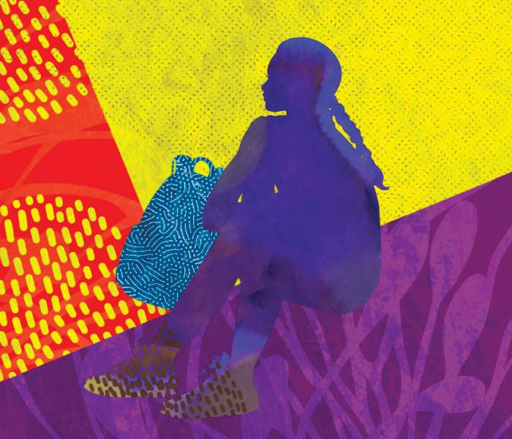There are robust examples of whole-child design today in schools and youth-development and community-learning settings across the United States. In the two schools described here, you will see the power of integration across all five principles of whole-child design and the overwhelming importance of putting relationships at the center of learning.

Collaborative Learning and Development at the Springfield Renaissance School
The Springfield Renaissance School³⁶ in Massachusetts is a regular, nonselective district school for grades 6–12 serving mostly students of color from low-income families. Ninety-five percent of its students graduate and are accepted into college. Most are the first in their families to go.
What is producing these remarkable results? Renaissance cultivates a learning community that supports, respects, and empowers students in a holistic way. Because students are known and valued as individuals with positive personal and academic identities, they are more confident and resilient in taking on unusually complex and meaningful work.
School staff collaborate to improve the cultural responsiveness of their curriculum and teaching, their active work for equity and anti-racism, the efficacy of their lessons, and the classroom cultures that foster positive relationships and bring out the best in students.
Students meet in small “Crews” (advisories) every day—and their Crews stay together from 6th through 8th grades and from 9th through 12th grades. Crews support the social and emotional health of students, foster their academic resilience and growth, affirm their identities (e.g., race, culture, language, gender identity, sexual orientation, physical abilities), and compel them to work on their character: to be responsible, respectful, courageous, and compassionate. Students see their role at school as more than their own success—they are responsible for the success of their Crew and classmates.
Building upon a foundation that meets academic standards and fosters deep knowledge, Renaissance educators invigorate learning through interdisciplinary projects, service-learning opportunities, and project-based learning expeditions, which call upon students to conduct research in the field that culminates in a product, presentation, or performance. The projects are also motivated by purpose, typically designed to contribute to the well-being of the community.
In Renaissance classrooms, teachers talk less. Students talk (and think) more. Lessons have explicit purpose, guided by learning targets for which students take ownership and responsibility. Student engagement strategies and activities differentiate instruction and maintain high expectations to bring out the best in all students, cultivating a culture of high achievement.

Developing Habits of Mind and Heart at East Palo Alto Academy
East Palo Alto Academy (EPAA)³⁷—a small public high school launched in a chronically marginalized and under-resourced community in California once so violence-ridden it was identified as the murder capital of the United States—transformed student outcomes by incorporating practices built on the science of learning and development. In a district where two-thirds of students once failed to graduate, the new school enabled 90 percent of students to graduate and 90 percent to go on to college by creating the conditions for cognitive, social, and emotional learning.
During the school’s first year, teachers identified the fundamental competencies necessary for success in school and in life, then infused them into every aspect of the school. Their Five Community Habits—personal responsibility, social responsibility, critical and creative thinking, application of knowledge, and communication—became the basis of rubrics used for guidance and evaluation in every class by every teacher.
The social, emotional, and cognitive skills, habits, and mindsets incorporated into the rubrics include personal awareness and self-management for attendance, participation, personal honesty, and care for others. Rubrics also include interaction and collaboration skills, empathy and perspective taking, and community building. Executive functions like planning, organizing, and managing projects; metacognitive skills like reflection for self-improvement; and capacities for perseverance exhibited by willingness to revise work are also incorporated into the rubrics.
Together, these rubrics form a framework that is used to teach students in a consistent and persistent manner what it means to be a student, a worker, and a member of their school community. Some skills, such as conflict resolution and study skills, are taught in advisory classes, while all are taught, modeled, and reinforced in academic and cocurricular settings. One student described these rubrics on the five habits as “the best thing for me over the last four years.”
Because teachers incorporate these skills and habits into content classes as well as advisory classes, students grow to have a thorough understanding of the standards, commonly reference them, and know what is needed to meet them. And because students are constantly reflecting on the skills in self-assessments, exhibitions, and student-led conferences, they internalize them deeply. Ericka, a student from the first graduating class, demonstrated her deep understanding of the habit of social responsibility as she reflected at her senior exhibition:
It was hard for me, because freshman year I was just really a cocky individual. I thought I knew it all; I didn’t want to work for anybody else, because I was big-headed. And part of this habit is how well you interact in a group. How well do you work with people who are not like you? If I put you in a group with [two other students], can you work with them? Can you get the job done? How do you move your group forward? … Are you interrupting me every time I’m trying to speak? … I would apply this [to the challenge of] being able to work with people who are not like you, who have different backgrounds from you, who have different viewpoints from you. Being able to tackle that in high school I think [will make it] easier for me to tackle it when I go to college.

Partnering for Play and Enrichment
Some schools and youth development organizations have seen the value of working more closely together to alleviate the exhaustion from the pandemic and, more importantly, to offer students many different experiences to discover their passions, interests, and capabilities. For example, Playworks is an organization that helps schools and districts make the most out of recess through onsite staffing, consultative support, professional development, and free resources. Playworks helps schools create safe, joyful, inclusive opportunities for children to play alongside adults. Students develop leadership and conflict resolution skills while priming their brains and bodies for academic success. A review found that the Playworks Coach service is one of only seven interventions to meet the highest criteria for evidence of impact under the Every Student Succeeds Act.³⁸
A more community-focused example is the Providence After School Alliance, a public-private partnership that aims to close opportunity gaps by expanding and improving quality afterschool learning opportunities. Middle and high school students throughout Providence, Rhode Island, are offered year-round access to free, hands-on learning and enrichment opportunities provided by over 80 community-based organizations four days per week. Students build solar-powered go-karts, study marine biology in Narragansett Bay, and can choose to learn how to act, dance, cook, sail, throw a pot, kick a soccer ball, or design a robot. During the multiweek sessions, students explore their career interests, deepen existing skills, and discover new activities with the guidance of adults with whom they build lasting relationships. Transportation, snacks, and meals are also provided free of cost.
With what we know today, we can build many more environments that help protect children from developmental harm, including racist policies and behaviors, and promote their healthy development and success as learners. The nonnegotiable elements of whole-child design described here will simultaneously ignite brain development and learning, promote wellness, support positive identity formation, and enable the acquisition of knowledge, skills, and mindsets that are critical for success in learning, work, and life and build resilience to future stresses.
In the design process, we can ask and answer the same question that researchers and practitioners in other fields have asked: What can we do that will work optimally for this specific child, in this context? This question will move scientists, educators, and youth development practitioners of all kinds to fundamentally different answers about the way our schools and learning systems of the future must be designed: toward integrated, holistic, and personalized processes, using tools, platforms, and support systems to integrate rigorous academic instruction with the intentional development of the skills and mindsets that all successful learners have.
Insights from brain science align profoundly with what so many parents want for their kids, and what so many teachers have been saying for years: that we can create a system that recognizes children as whole people, values their assets, and supports them to excel in myriad ways.
The message in the science is so optimistic: context shapes the expression of our genetic attributes. This is the biological truth. And schools designed using the levers of human development—so that what one child can do, nearly all children can do under highly favorable conditions—can become our new learning system: a system designed to see and unleash talent and potential and ensure that all young people can thrive.³⁹ This vision constitutes a transformational shift in the purpose and potential of our learning systems, and a dismantling of the systems and laws that constrain this vision, grounded in what we know today about human development, the development of the brain, and learning science.

Pamela Cantor, MD, is the founder and senior science advisor of Turnaround for Children; she is also a governing partner of the Science of Learning and Development Alliance and a visiting scholar at the Harvard Graduate School of Education. As a child and adolescent psychiatrist for nearly two decades, she saw the impact of concentrated poverty and the need for new systems and supports in schools and communities to foster healthy learning and development. Cantor’s scholarship focuses on synthesizing research from multiple disciplines to bring meaning and actionable insights to whole-child development—especially for children in chronically under-resourced neighborhoods. This article is adapted from Whole-Child Development, Learning, and Thriving: A Dynamic Systems Approach, by Pamela Cantor, Richard M. Lerner, Karen J. Pittman, Paul A. Chase, and Nora Gomperts (Cambridge University Press, 2021).
*The research on human development described here has profound implications for the measurement of learning. Children and their contexts are not only related to one another, they are contingent and mutually inﬂuential. If this could be more accurately understood and measured, the educational and opportunity path of each child and each context could be enhanced. Although much work remains to be done and a measurement discussion is outside the scope of this article, educators and policymakers should be alert to the necessity of completely rethinking current assessment practices and policies. (return to article)
†Some educators and researchers find it helpful to think about learning settings in three broad educational categories: formal (e.g., classroom instruction), nonformal (e.g., recreation center swimming lessons), and informal (e.g., everyday conversations and activities). (return to article)

Endnotes
1. T. Rose, foreword, in P. Cantor et al., Whole-Child Development, Learning, and Thriving: A Dynamic Systems Approach (Cambridge, UK: Cambridge University Press, 2021), turnaroundusa.org/read-the-foreword-by-todd-rose-from-the-book-whole-child-development-learning-and-thriving.
2. T. Lewallen et al., “The Whole School, Whole Community, Whole Child Model: A New Approach for Improving Educational Attainment and Healthy Development for Students,” Journal of School Health 85, no. 11 (2015): 729–39.
3. M. Brackett, N. Elbertson, and S. Rivers, “Applying Theory to the Development of Approaches to SEL,” in Handbook of Social and Emotional Learning: Research and Practice, ed. J. Durlak et al. (New York: Guilford Press, 2015), 20–32.
4. S. Jones and J. Kahn, The Evidence Base for How We Learn: Supporting Students’ Social, Emotional, and Academic Development (Washington, DC: Aspen Institute, 2017).
5. M. Bornstein, “Fostering Optimal Development and Averting Detrimental Development: Prescriptions, Proscriptions, and Specificity,” Applied Developmental Science 23, no. 4 (2019): 340–45; and T. Rose, The End of Average: How We Succeed in a World That Values Sameness (New York: HarperCollins, 2016).
6. M. Bornstein, ed., Handbook of Parenting (Abington, UK: Routledge, 2019); U. Bronfenbrenner and P. Morris, “The Bioecological Model of Human Development,” in The Handbook of Child Psychology: Theoretical Models of Human Development, vol.1, 6th ed., ed. W. Damon and R. Lerner (Hoboken, NJ: Wiley, 2006), 793–828.
7. M. Irby et al., “Building Forward Together: Toward Equitable Ecosystems for Young People,” in It Takes an Ecosystem: Understanding the People, Places, and Possibilities of Learning and Development Across Settings, ed. T. Akiva and K. Robinson (Information Age Publishing, forthcoming).
8. A. Masten, Ordinary Magic: Resilience in Development (New York: Guilford Press, 2014).
9. R. Lerner, Liberty: Thriving and Civic Engagement Among America’s Youth (Thousand Oaks, CA: Sage Publications, 2004); and D. Osher et al., “Drivers of Human Development: How Relationships and Context Shape Learning and Development,” Applied Developmental Science 24, no. 1 (2020).
10. B. McEwan, “The Brain on Stress: Toward an Integrative Approach to Brain, Body, and Behavior,” Perspectives on Psychological Science 8, no. 6 (2013): 673–75.
11. Osher et al., “Drivers of Human Development.”
12. R. Sampson, “The Characterological Imperative: On Heckman, Humphries, and Kautz’s ‘The Myth of Achievement Tests: The GED and the Role of Character in American Life,’ ” Journal of Economic Literature 54, no. 2 (2016): 493–513.
13. M. Immordino-Yang, L. Darling-Hammond, and C. Krone, “Nurturing Nature: How Brain Development Is Inherently Social and Emotional, and What This Means for Education,” Educational Psychologist 54, no. 3 (2019): 185–204.
14. B. Bloom, ed., Developing Talent in Young People (New York: Ballantine Books, 1985); and M. Bornstein and D. Putnick, The Architecture of the Child Mind: g, Fs, and the Hierarchical Model of Intelligence (New York: Routledge, 2019).
15. Rose, The End of Average.
16. L. Vygotsky and M. Cole, Mind in Society: The Development of Higher Psychological Processes (Cambridge, MA: Harvard University Press, 1978).
17. Rose, The End of Average.
18. C. Dweck, Mindset: The New Psychology of Success (New York: Ballantine, 2016).
19. McEwan, “The Brain on Stress”; and G. Slavich and S. Cole, “The Emerging Field of Human Social Genomics,” Clinical Psychological Science 1 (2013): 331–48.
20. C. Raeff, Exploring the Dynamics of Human Development: An Integrative Approach (New York: Oxford University Press, 2016).
21. D. Osher et al., Thriving, Robust Equity, and Transformative Learning and Development: A More Powerful Conceptualization of the Contributors to Youth Success (Washington, DC: American Institutes for Research and Forum for Youth Investment, 2020); and M. Tucker, Race in America 2020 (Washington, DC: National Center on Education and the Economy, 2020), ncee.org/2020/06/race-in-america-2020.
22. Lerner, Liberty.
23. M. Spencer, “Phenomenological Variant of Ecological Systems Theory (PVEST): A Human Development Synthesis Applicable to Diverse Individuals and Groups,” in Handbook of Child Psychology: Theoretical Models of Human Development, vol. 1, 6th ed., ed. W. Damon and R. Lerner (Hoboken, NJ: Wiley, 2006), 829–94.
24. D. Moore, The Developing Genome: An Introduction to Behavioral Epigenetics (New York: Oxford University Press, 2015).
25. M. Pigliucci and G. Mueller, “Elements of an Extended Evolutionary Synthesis,” in Evolution—The Extended Synthesis, ed. M. Pigliucci and G. Mueller (Cambridge, MA: MIT Press, 2010), 3–17.
26. Slavich and Cole, “The Emerging Field.”
27. T. Misteli, “The Cell Biology of Genomes: Bringing the Double Helix to Life,” Cell 152 (2013): 1209–12.
28. D. Hebb, “Drives and the C. N. S. (Conceptual Nervous System),” Psychological Review 62, no. 4 (1955): 243–54.
29. K. Fischer and T. Bidell, “Dynamic Development of Action and Thought,” in Handbook of Child Psychology: Theoretical Models of Human Development, vol. 1, 6th ed., ed. W. Damon and R. Lerner (Hoboken, NJ: Wiley, 2006), 313–99.
30. C. Lee, “Soaring Above the Clouds, Delving the Ocean’s Depths: Understanding the Ecologies of Human Learning and the Challenge for Education Science,” Educational Researcher 39, no. 9 (2010): 643–55.
31. Vygotsky and Cole, Mind in Society.
32. I. Kendi, How to Be an Antiracist (New York: Penguin Random House, 2019), 103.
33. N. Nasir et al., Handbook of Cultural Foundations of Learning (New York: Routledge, 2020).
34. P. Cantor et al., Whole-Child Development, Learning, and Thriving: A Dynamic Systems Approach (Cambridge, MA: Cambridge University Press, 2021), 21–22.
35. Fischer and Bidell, “Dynamic Development.”
36. This description is adapted from L. Darling-Hammond et al., Design Principles for Schools: Putting the Science of Learning and Development into Action (Palo Alto, CA, and Washington, DC: Learning Policy Institute and Turnaround for Children, 2021).
37. This description of East Palo Alto Academy is adapted from L. Darling-Hammond et al., Be the Change: Reinventing School for Student Success (New York: Teachers College Press, 2016).
38. J. Fortson et al., Impact and Implementation Findings from an Experimental Evaluation of Playworks: Effects on School Climate, Academic Learning, Student Social Skills and Behavior (Princeton, NJ: Mathematica Policy Research, 2013).
39. B. Bloom, “The 2 Sigma Problem: The Search for Methods of Group Instruction as Effective as One-to-One Tutoring,” Educational Researcher 13, no. 6 (1984): 4–16.
[Illustrations by Erin K. Robinson]
American Educator, Fall 2021

